## 

## 

# 

# **Movie Recommendation Website Report**

## 

## **[Project Development]**

## 

## **By:**

Siva S

Mariselvi M

## **Table of Contents Page No**

## **Introduction 3**

## **Features 3**

## **User Authentication 3**

## **Homepage 3**

## **Movie Page 3**

## **Rating Page 3**

## **Architecture 3**

## **Frontend 3**

## **Backend 4**

## **Database 4**

## **Workflow 4**

## **User Authentication 4**

## **Movie Browsing 4**

## **Rating and Reviews 4**

## **Recommendations 4**

## **Technologies Used 5**

## **Frontend 5**

## **Backend 5**

## **Database 5**

## **Deployment 5**

**7.Requirement Analysis 5**

## **8.Conclusion 14**

## 

## 

## **Introduction:**

This report outlines the development of a Movie Recommendation Website that allows users to log in, sign up, browse movies, rate them, and receive personalized recommendations. The platform features a React-based frontend and a Firebase backend, ensuring dynamic functionality and a seamless user experience.

## **Features:**

### **User Authentication:**

* **Login and Signup**: Users can create an account or log in using existing credentials.
* **Session Management**: User sessions are maintained securely using Firebase Authentication.

### **Homepage:**

* **Movie Categories**: Displays curated lists of movies such as trending, top-rated, and recommended.
* **Search Bar**: Allows users to search for movies by title or genre.
* **Personalized Recommendations**: Registered users receive movie suggestions based on their viewing and rating history.

### **Movie Page:**

* **Details View**: Displays movie information such as title, genre, release year, synopsis, and cast.
* **User Interactions**: Users can rate, comment, and save movies to their watchlist.

### **Rating Page:**

* **Rate Movies**: Users can rate movies on a scale (e.g., 1 to 10 stars).
* **Review Section**: Users can leave written reviews and view other users' ratings.
* **Feedback Integration**: Ratings and reviews contribute to the recommendation algorithm.

## **Architecture:**

### **Frontend:**

The frontend is built using **React** for a responsive and interactive user interface.

* **Homepage**: Features dynamically loaded movie lists using React components.
* **Movie Page**: Uses React hooks and Firebase queries to retrieve movie details.
* **Forms**: Secure forms for login, signup, and submitting reviews.

### **Backend:**

The backend functionality is handled by **Firebase**:

* **Firebase Authentication**: Manages user signup, login, and session persistence.
* **Firebase Firestore**: A NoSQL database for storing user data, movie details, and ratings.
* **Firebase Functions**: Used for server-side logic such as recommendation algorithms.

### **Database:**

A **Firebase Firestore** database is used to store and manage data:

* **Collections**:
  + **Users**: Stores user profiles, credentials, and preferences.
  + **Movies**: Contains movie information such as title, genre, and ratings.
  + **Ratings**: Records user ratings and reviews.

## **Workflow:**

### **User Authentication:**

1. User submits login/signup form.
2. Firebase Authentication validates credentials and manages sessions.

### **Movie Browsing:**

1. Homepage fetches movie lists from Firestore.
2. Users can click on a movie to view details.

### **Rating and Reviews:**

1. User submits a rating or review.
2. Firestore updates the database and triggers a recommendation update via Firebase Functions.

### **Recommendations:**

1. Firebase Functions analyze user preferences and interactions.
2. Recommendations are displayed on the homepage.

## **Technologies Used:**

### **Frontend**

* **React**: For UI/UX.
* **Firebase Hosting**: For deploying the frontend.

### **Backend**

* **Firebase**: For backend services including authentication, database, and functions.

### **Database**

* **Firebase Firestore**: NoSQL database for managing data.

## **Deployment:**

* **Frontend**: Hosted on Firebase Hosting.
* **Backend**: Managed through Firebase Functions and Firestore.

## **Requirement Analysis:**

The core pages and functionalities of the Movie Recommendation Website include:

### **Login Page:**

* Allows users to log in using their email and password.
* Firebase Authentication ensures secure login and session management.



### **Signup Page:**

* Enables new users to create an account by providing necessary details such as email and password.
* Implements validation and error handling for user input.



### **Homepage:**

* Displays a dynamic collection of movies including trending, top-rated, and recommended categories.
* Provides a search bar for movie lookup and personalized recommendations for logged-in users.

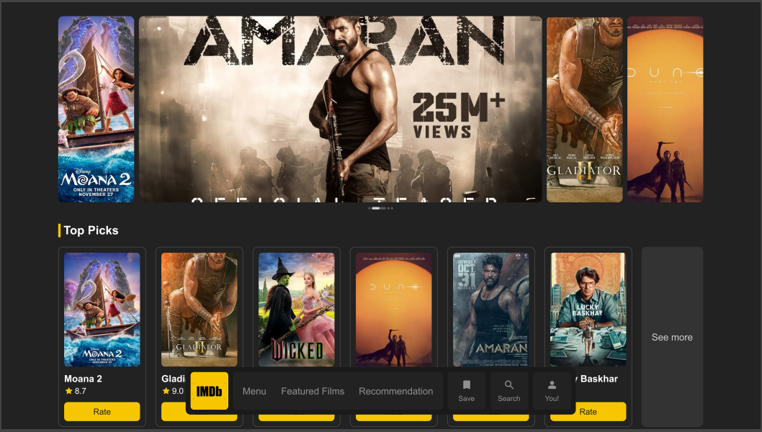

### **Movie Page:**

* Provides detailed information about a selected movie.
* Allows users to interact with the movie by rating, reviewing, and adding it to their watchlist.

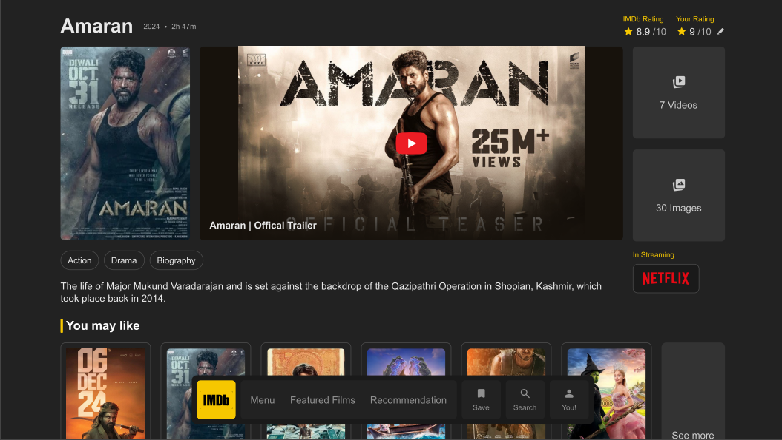

### **Rating Page:**

* Enables users to rate movies on a predefined scale (e.g., 1-10 stars).
* Displays other users' reviews and ratings for a movie.
* Contributes data to the recommendation engine for better suggestions.

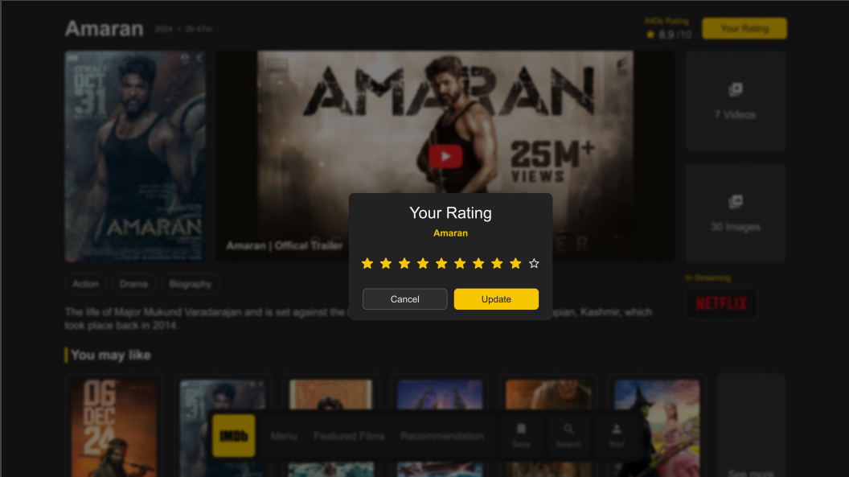

**Work:**

**Login Page:**



**SignUp Page:**



**Home Page:**

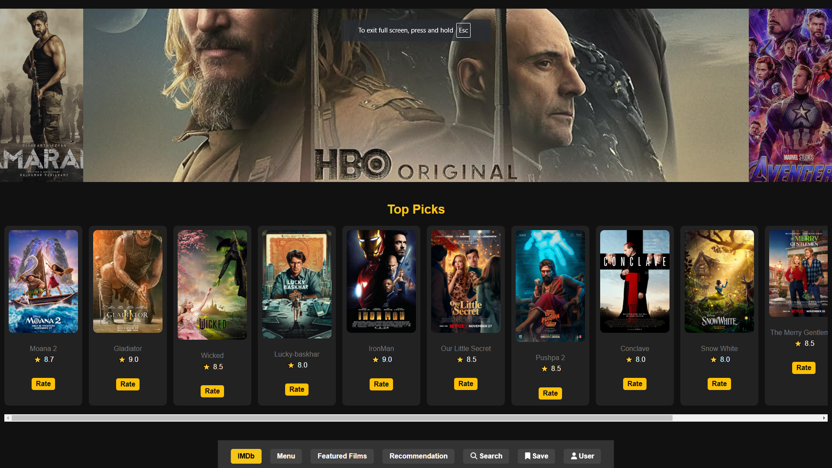

**Movie Page:**

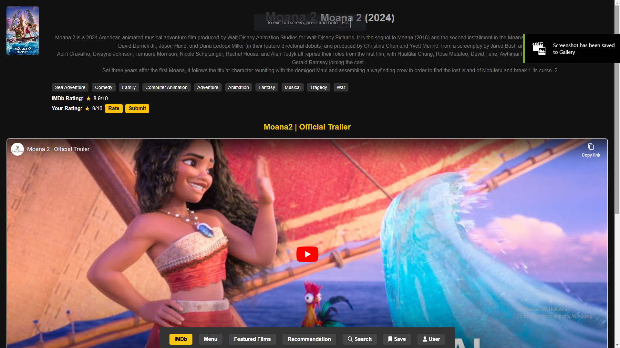

**Rating Page:**

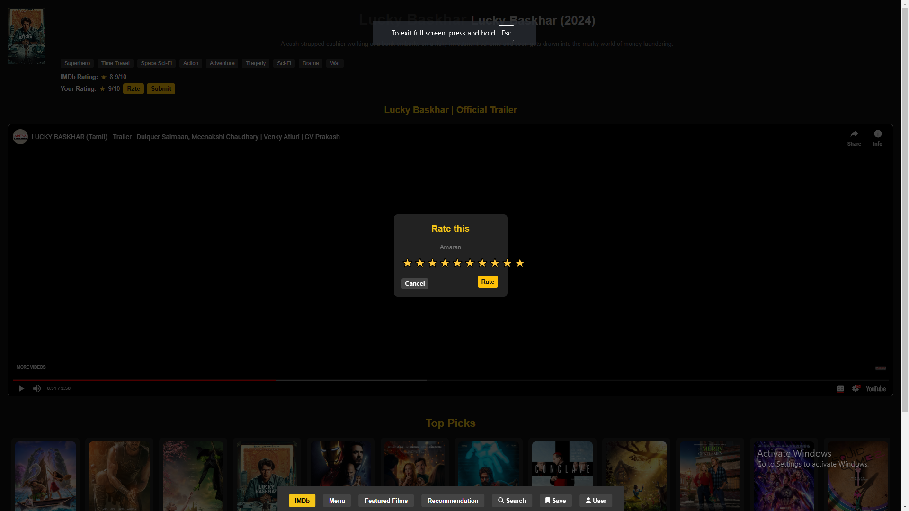

**Imdb Page:**

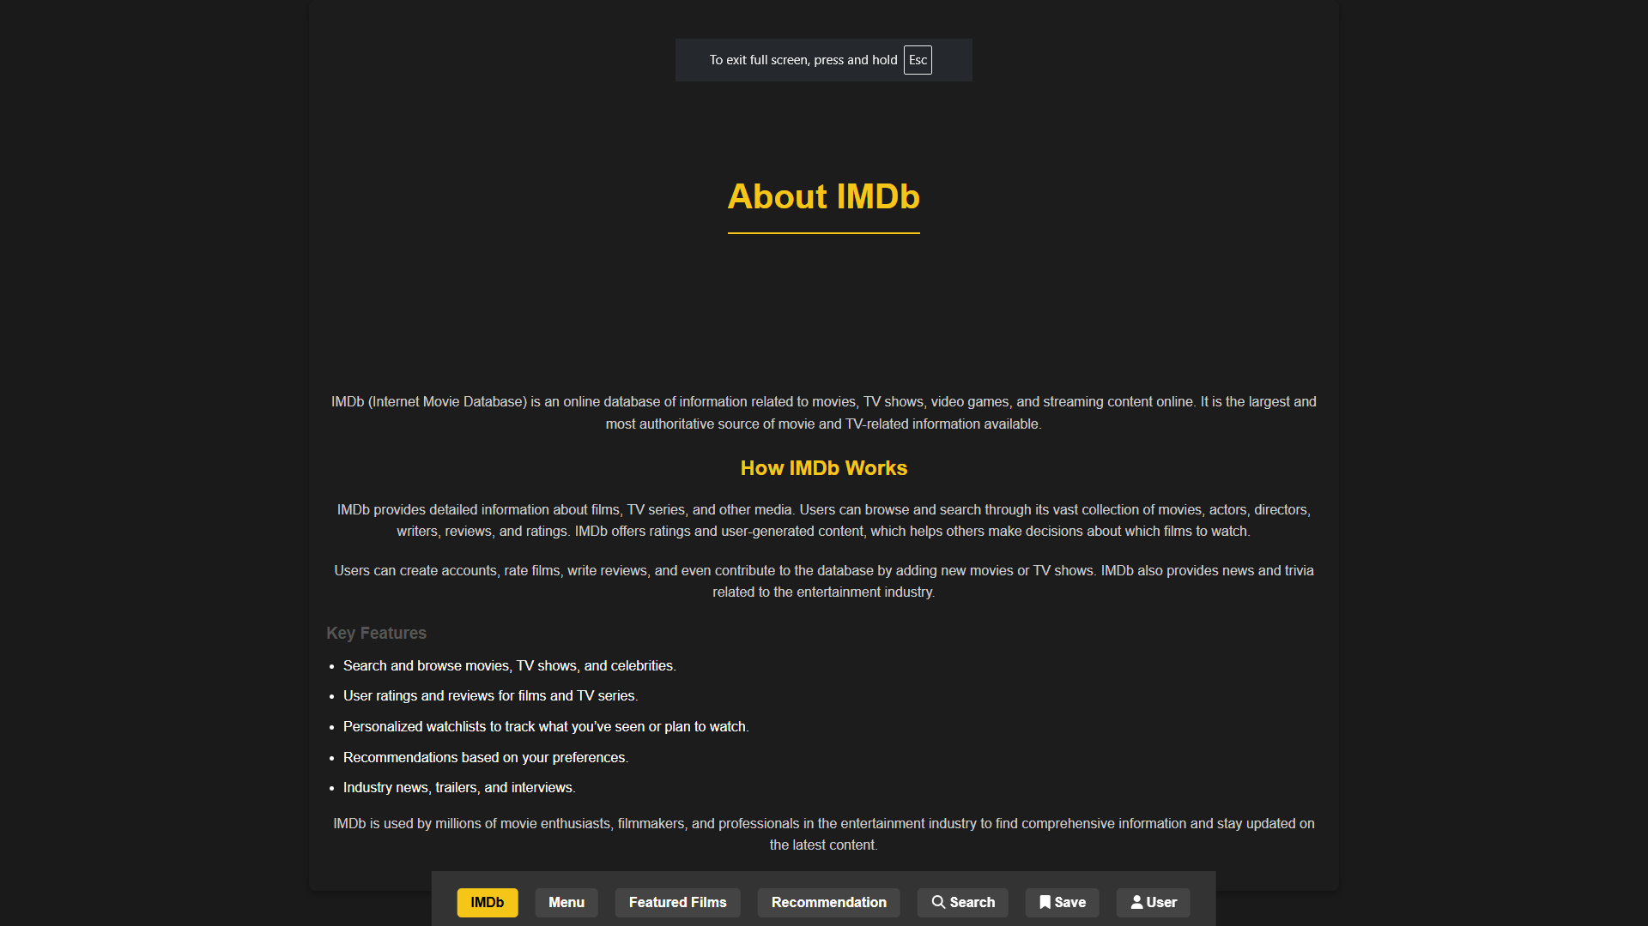

**Featured Page:**

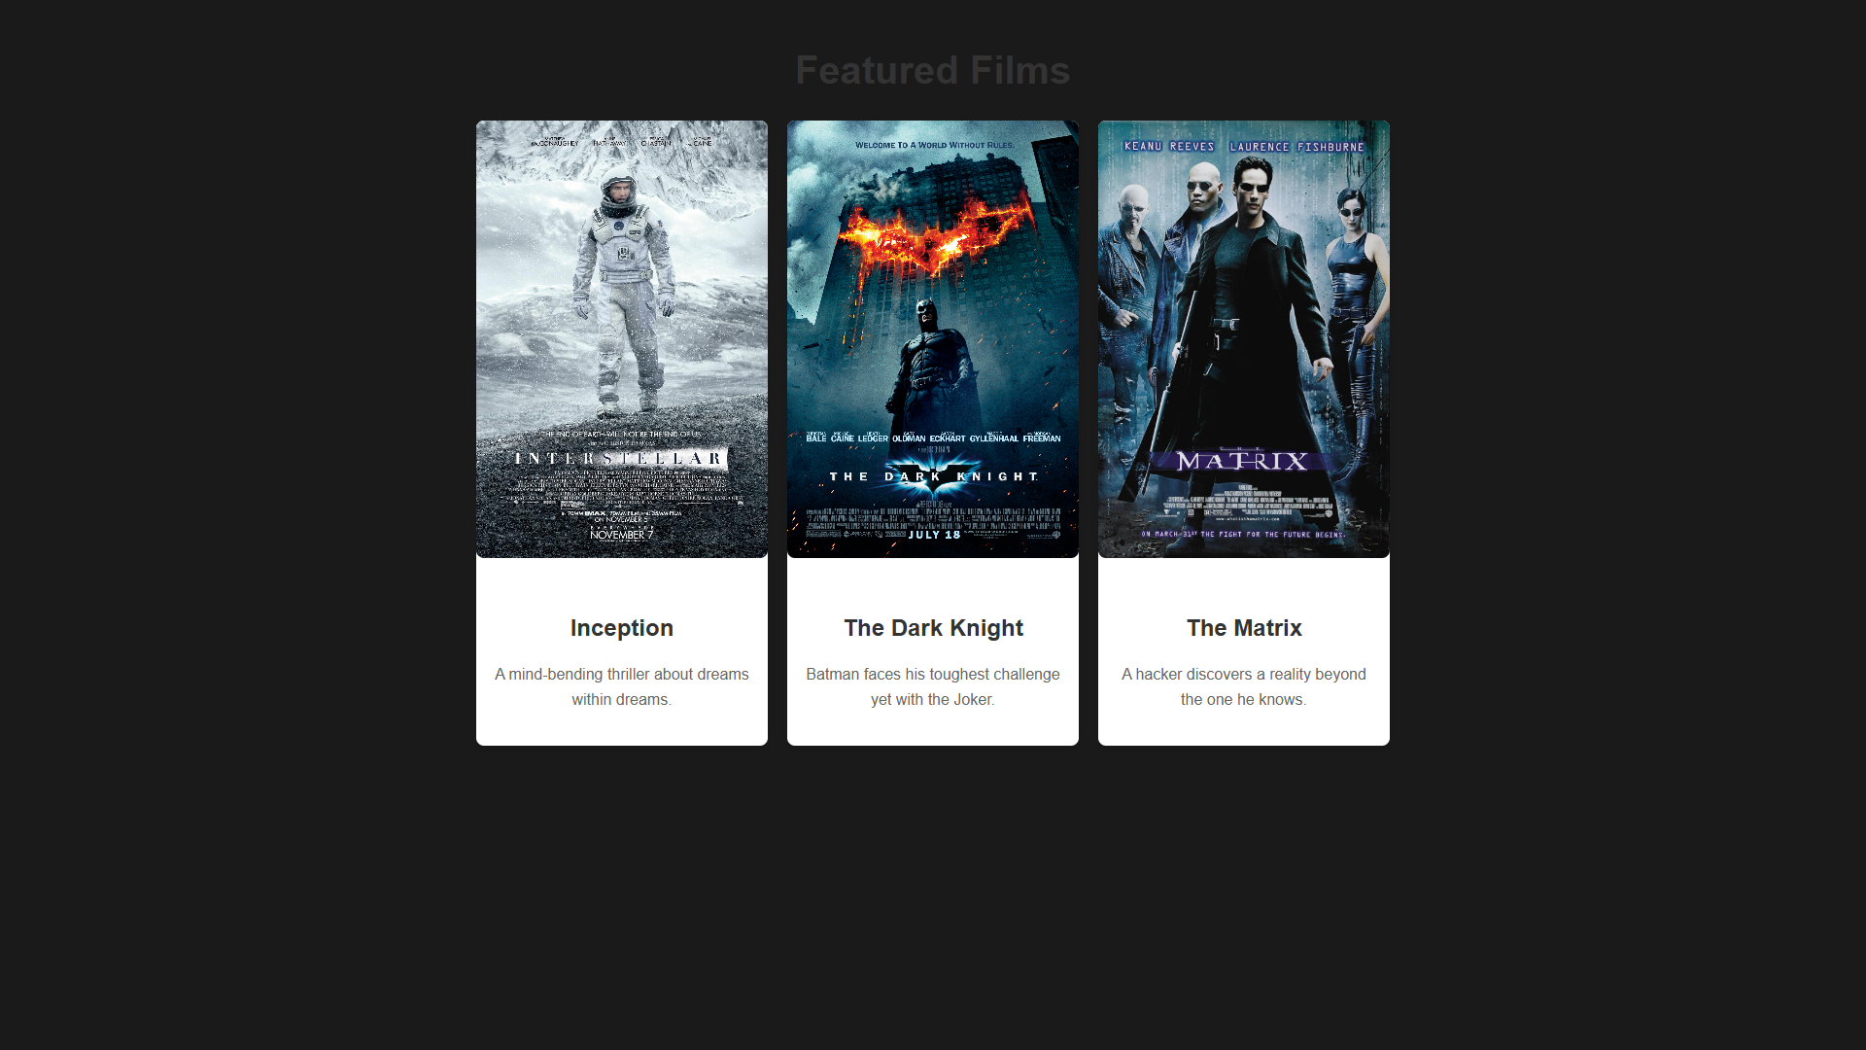

**Recommendation Page:**

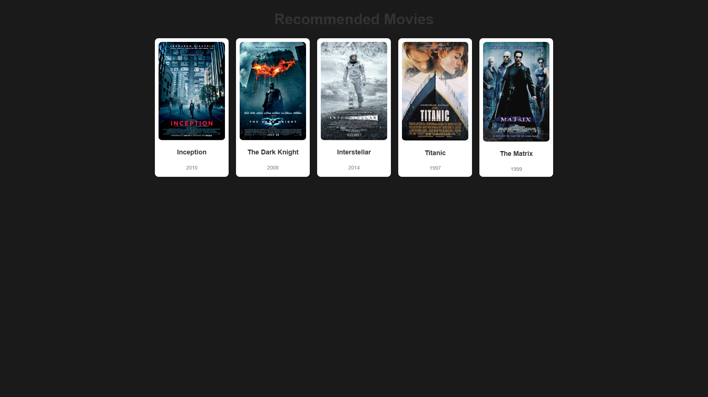

**Search Page:**

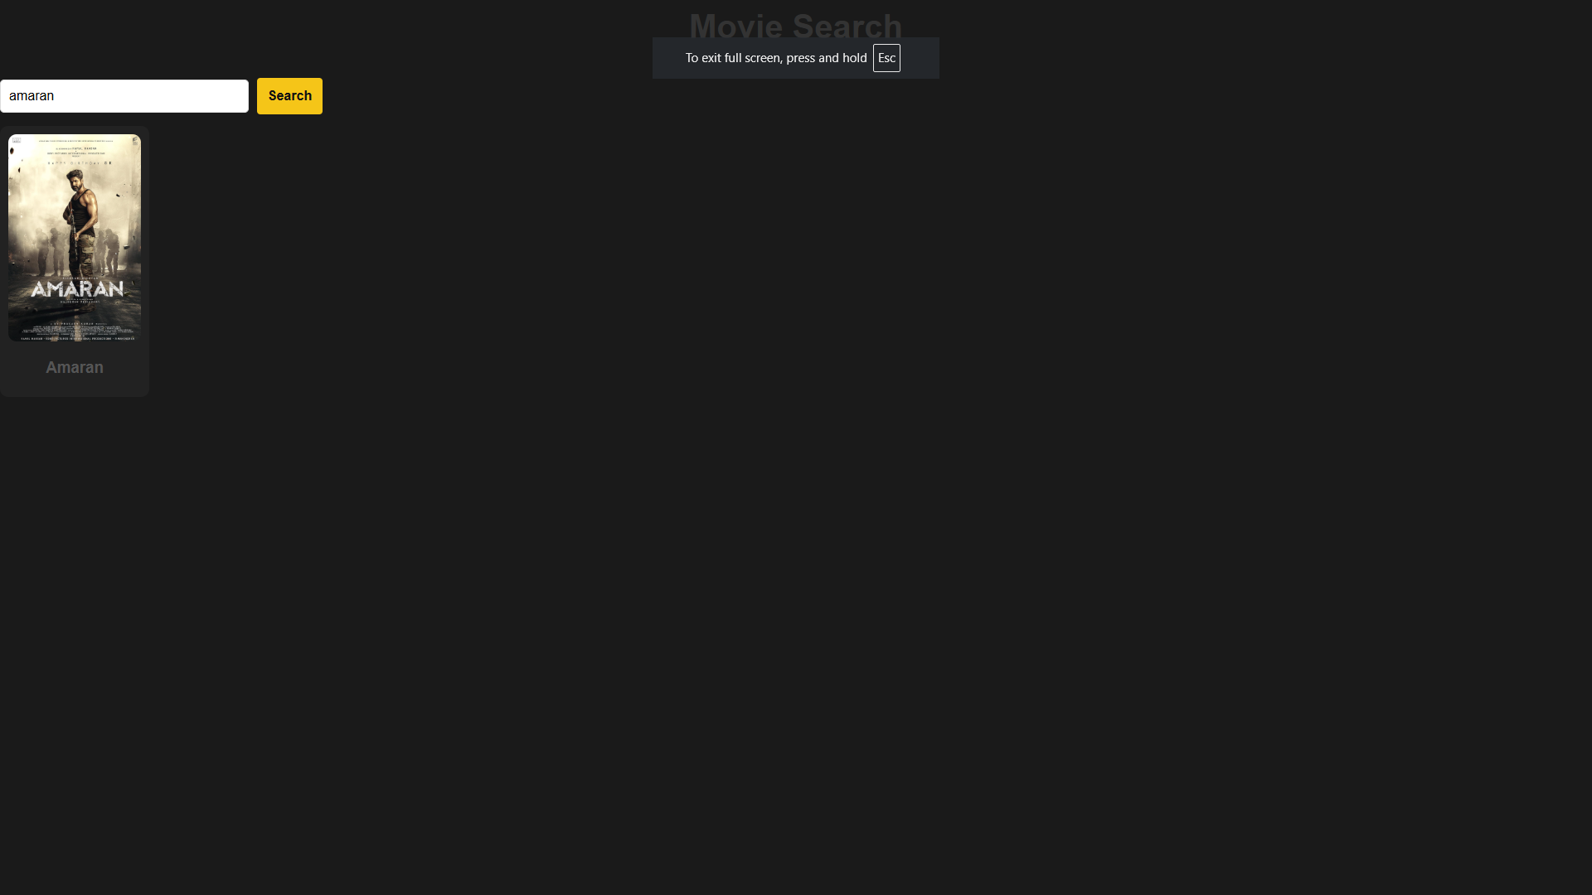

**FavouriteMovies Page:**

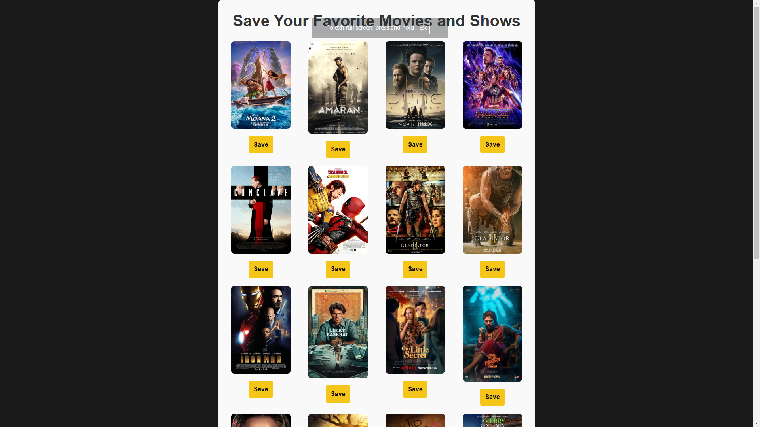

**User Page:**

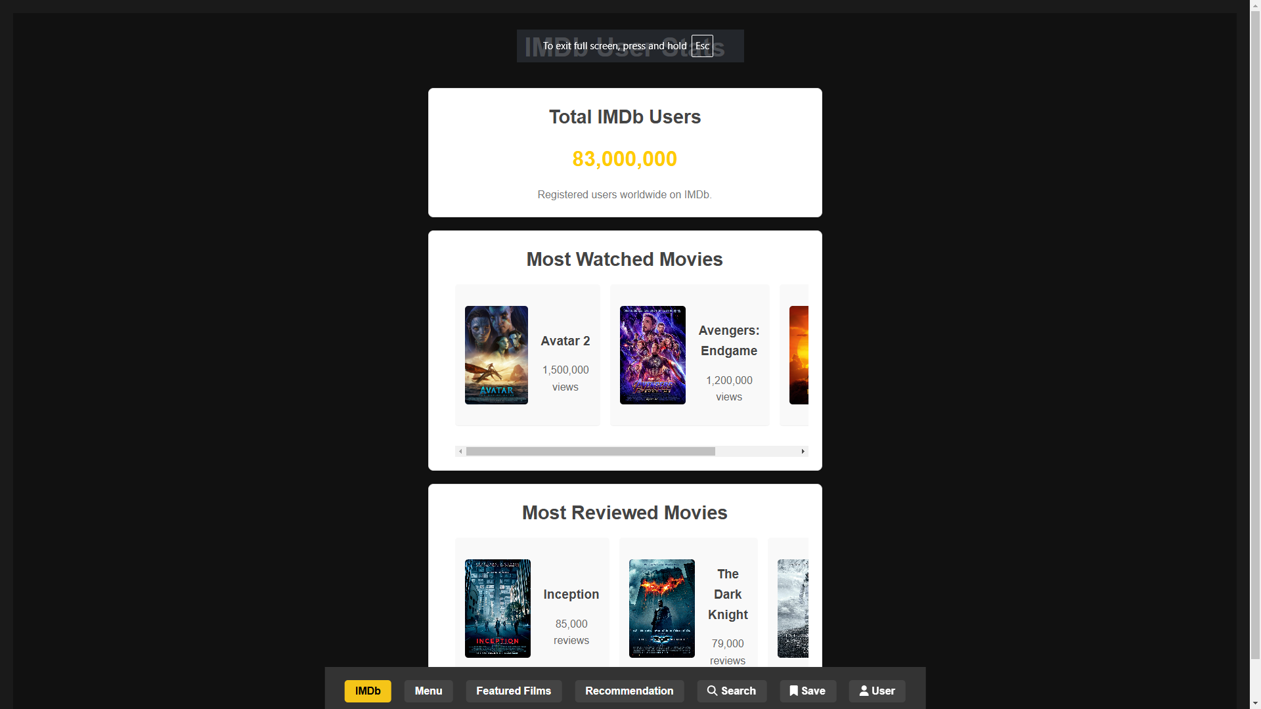

**Imdb Menu Page:**

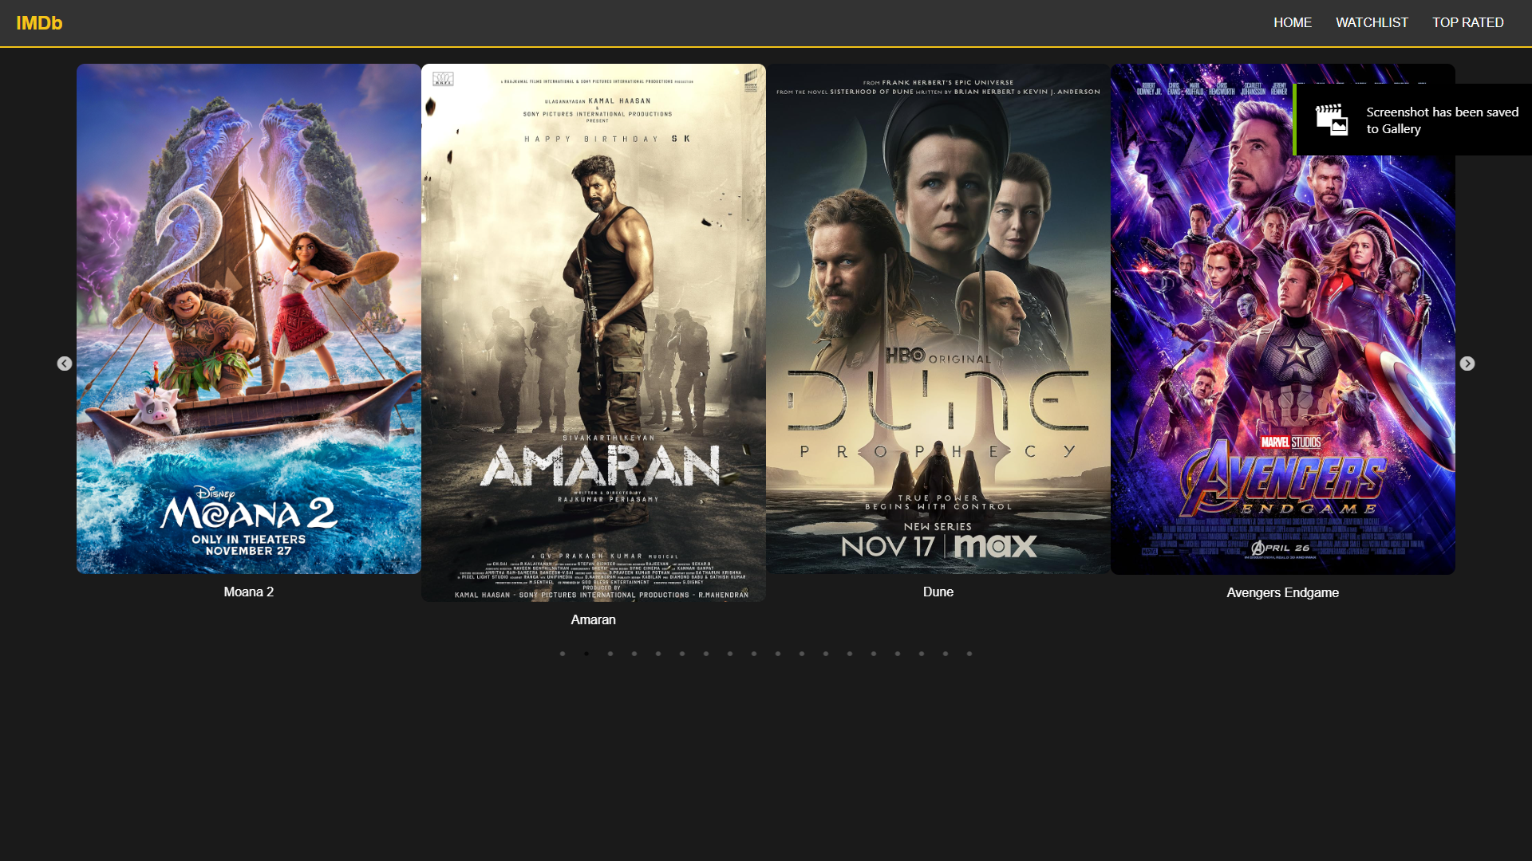

## **Conclusion:**

This Movie Recommendation Website combines React and Firebase technologies to deliver a personalized and engaging experience. The seamless integration of the frontend, backend, and database ensures efficient operation and scalability.

**Links:**

**MovieRecommendationIMDbPage Url (Hosted):**

[**https://sivatech24.github.io/MovieRecommendationImdb/**](https://sivatech24.github.io/MovieRecommendationImdb/)

**MovieRecommendationIMDb React Project Files:**

[**https://github.com/Sivatech24/MovieRecommendationImdbProject**](https://github.com/Sivatech24/MovieRecommendationImdbProject)

**GoogleDrive Link For Zip Files:**

[**CrystalDeltaProject**](https://drive.google.com/drive/folders/1mSV6dRN6TxOIr1tb3tuaX-X_26iF5Zxj?usp=sharing)

[**https://drive.google.com/drive/folders/1mSV6dRN6TxOIr1tb3tuaX-X_26iF5Zxj?usp=sharing**](https://drive.google.com/drive/folders/1mSV6dRN6TxOIr1tb3tuaX-X_26iF5Zxj?usp=sharing)

**GitHub All Project Files:**

[**https://github.com/Sivatech24/MovieRecommendationIMDbAllFilesUsed**](https://github.com/Sivatech24/MovieRecommendationIMDbAllFilesUsed)